**Computer Lab 1**

*Computer arithmetic*

**REPORT**

Subject: Computational Statistics

Lab Date: April 9, 2010

**Prepared for:**

Oleg Sysoev

**By:**

Victoria Fomichov

***Assignment 1: Be careful with ‘==’***

*A pupil of a school is bad in arithmetic but good in programming. He writes a program to check if 1/3-1/4==1/12:*

*x1<-1/3;*

*x2<-1/4;*

*if (x1-x2==1/12){*

*print("Teacher said true")*

*} else{*

*print("Teacher lied")}*

1. *Check the result of this program. Comment why this happened.*

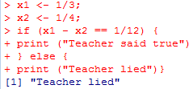

THE answer we get (*Teacher lied*) was not the expected, the thing is that if we let the computer first made the division in x1 and x2 those result are rounded towards zero and afterwards when we made the subtraction the operations doesn’t result in the same number as the division 1/12.

1. *Specify how the program can be modified to give a correct result*

To avoid this problem we need to rewrite this operation in a way that leaves the division to the end.

That can be easily done rewriting the same operation but using some easy mathematical rules.

We know that:

$$\frac{1}{3}-\frac{1}{4}= \frac{\left(1*4\right)-\left(1*3\right)}{3*4}$$

Writing as in the second part we made the division at the end.

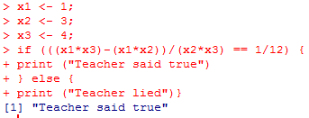

***Assignment 2: Derivative***

*A widely known way to compute the derivative of function f(x) in point x is to use*

$$f^{'\left(x\right)}=\frac{f\left(x+ε\right)-f(x)}{ε}$$

1. *Write your own function computing the derivative of function f(x)=|x| in this way. Take ε=10-15*

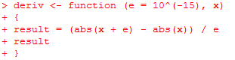

1. *Compute your derivative function at point x=100000.*



1. *What is the value you obtained? What is the real value of the derivative? Explain the reason behind the discovered difference.*

I obtained that the derivative of x id 0. The real answer should be 1. The reason is that after my function has calculated the term (abs( x + e)) the result is to large and I rounded to abs(x), and afterward that gets a division (0/e) = 0 and not the one we should have got (e/e) = 1.

***Assignment 3: Variance***

*A known formula for estimating variance is*

$$Var\left(x\right)=\frac{1}{n-1}\left(\sum_{i=1}^{n}{x_{i}^{2}-\frac{1}{n}}{\left(\sum_{i=1}^{n}{x_{i}}\right)}^{2}\right)$$

1. *Write your own function myvar estimating variance in this way*

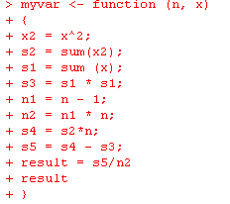

1. *Generate vector x with 10000 random numbers, normally distributed with mean 108 and variance 1*



1. *For each subset Xi= {x1…xi}, i=1…10000 compute difference Yi= myvar(x)-var(x), where var(x) is a standard variance estimation function in R. Plot the dependence Yi on Xi. Draw necessary conclusions. How well your function works? What is the reason behind such behavior?*

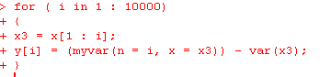

The above presented code is the one I made to calculate the estimated variance for all the different Xi.